Name: _______________________ Date: ___________________________

Fruits and Vegetables

Match the fruits and vegetables with their names.

Color the fruits and vegetables that you like.

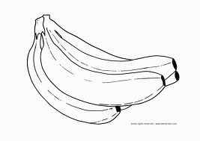 Strawberry Lettuce 

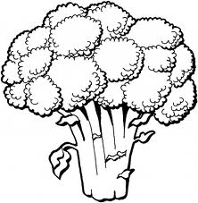 Carrot Lemon 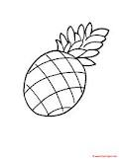

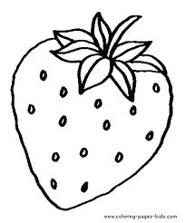 Banana Tomato 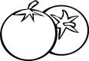

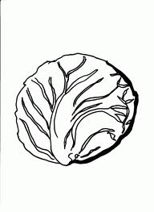 Apple Pear 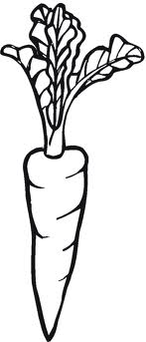

 Corn Broccoli 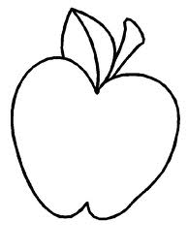

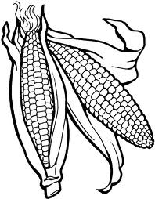 Pineapple