☺ READ AND COMPLETE WITH THE CORRECT FORM OF THE VERB IN BRACKETS.

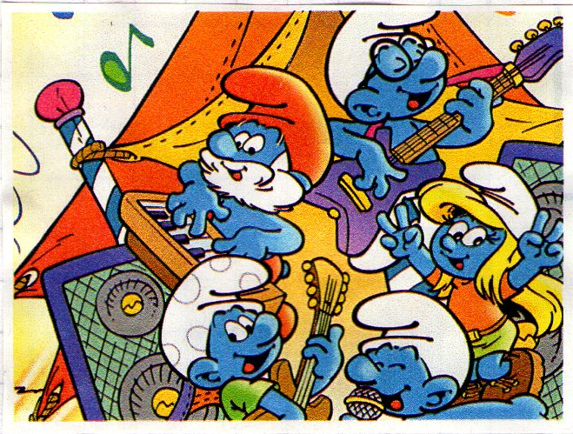
“The Smurfs”_______________(be) a cartoon from the ‘80s. The Smurfs_____________(live) in a village and Papa Smurf______________(be) their leader. He__________________(not wear) a white hat as the other smurfs: his hat________________(be) red. In the picture, he_______________(play) the piano. Brainy Smurf and Jokey Smurf_________________(play) the guitar. Brainy often_____________(think) he is the most intelligent Smurf in the village, but he__________(be) usually wrong. He always__________(wear) a pair of glasses and a white hat. Jokey____________(be) the funny Smurf. He____________(enjoy) playing tricks on the other Smurfs. Harmony Smurf____________(love) to play the trumpet, but he___________(not do) it well. In the picture, he__________(sing). Smurfette________________(not be) the only female Smurf in the village: there____________(be) other two girls. She________________(have) long blond hair and big eyes. In the picture, she______________(not play) any instrument.

☺ NOW ANSWER THE FOLLOWING QUESTIONS:

- What colour are the Smurfs?
- Where do the Smurfs live?
- Who is Papa Smurf?
- Does he wear a red hat?
- What is Brainy doing in the picture?
- What does Jokey enjoy doing?
- Does Harmony play the trumpet well?
- Is Smurfette the only girl in the village?

